Student_Name…………………………………………..Fokwen Bechem, Emmanuel

Student_Number………………………………………293370

Course_Code……………………………………………..MIS 500

Module8……………………………………………………Portfolio project-option1-R portfolio project.

***Overview, analytical objective, data source and model selection***

For my portfolio project, proposal I have chosen to examine the relationship between Gross Domestic Product and a country’s currency exchange rate building on the foundation set on the portfolio milestone in module4.

GDP measures the dollar value of all the goods and services produced by a country over a given period of time usually in a year. GDP could be measured via the income approach, the expenditure approach or the productivity approach and all methods should yield the same result if proper statistics are kept.

The exchange rate of a currency is the value or price of a country’s currency in terms of another currency, i.e. how much a currency is worth in another currency.

I am interested in investigating if there is a correlation between GDP and exchange rates using simple linear regression and hypothesis testing. I would like to determine the nature of the correlation whether negative or positive and the strength of the correlation whether strong or weak using quarterly economic data of GDP and currency exchange rates USD vs EUR of a hypothetical country between 2010 and 2018 downloaded from the MIS 470-Foundations of Data Science course website.

***Analytics questions to be answered;***

This portfolio project sets out to find answers to the below questions;

-Is there a relationship between GDP and Exchange Rates?

-What’s the nature of the relationship?

-What’s the strength of the relationship?

-Are the results of the analytical findings consistent with real world economic expectations?

***Identifying the key variables in the model***

For the regression analysis, the dependent variable will be the Currency exchange rate USEUR while the predictor or independent variable will be the GDP quarterly values between 2010 and 2018.

***Expectations of the analytical results***

Because in the real world, strong currencies are associated with countries with big economies and high living standards like the US, UK, EU, Canada, Japan, Switzerland etc, the normal expectation is for the data to show a strong positive correlation between GDP and high exchange rates. However though, there are notable exceptions where big GDP values may not be associated with strong currencies. For example, China is the second largest economy in the world but her currency exchange rate vis-à-vis the dollar, euro is much lower. Another example is the US and UK. The US economy is much bigger than the UK’s but the dollar is weaker than the pound. This may happen for trading reasons since the stronger a country’s currency, the more expensive her exports will be on the international market other things being equal. Moreover, it’s worth mentioning that the activities of central banks trying to fight inflation, unemployment and boost domestic investment as well as the speculative activities of investors on the stock market and investment banks also affect currency exchange rates, GDP aside.

***Stating the Null and Alternative hypotheses***

**Null Hypothesis *(Ho):*** Is that the population correlation coefficient is zero. In other words, there is no correlation between GDP and exchange rates.

***Alternative Hypothesis (Ha****):* Is that the population correlation coefficient is positive, meaning a positive linear relationship between GDP and Exchange rates (USEUR) exists.

***Data Analysis and output using R Studio***

The below screen shots show the GDP and exchange rate Excel data downloaded from the MIS 470-Foundations of Data Science website and imported to R studio for analysis. From this data, regression analysis and hypothesis testing were performed using R. Also, summary statistics of the data were calculated. First the code is presented, followed by the code output and interpretation.

***Excerpt of the Excel file imported to R studio***

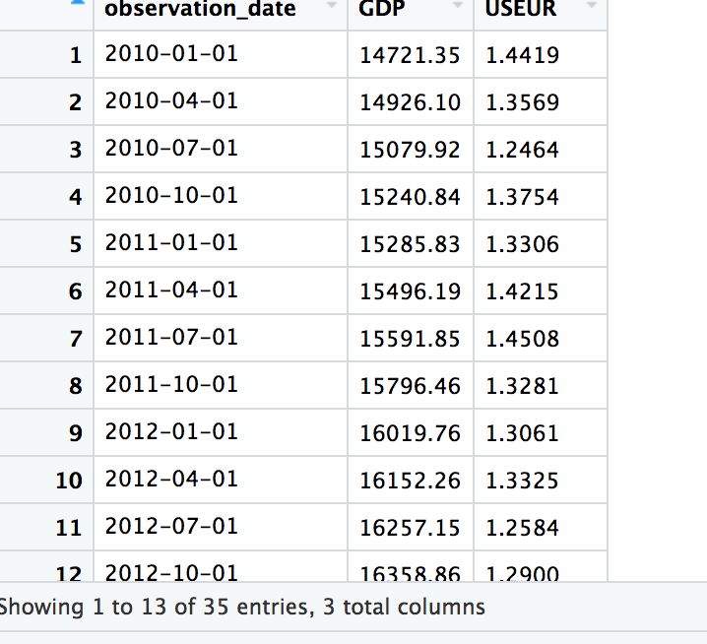

***Code for the linear regression model, summary statistics, scatter plot and regression line of best fit.***

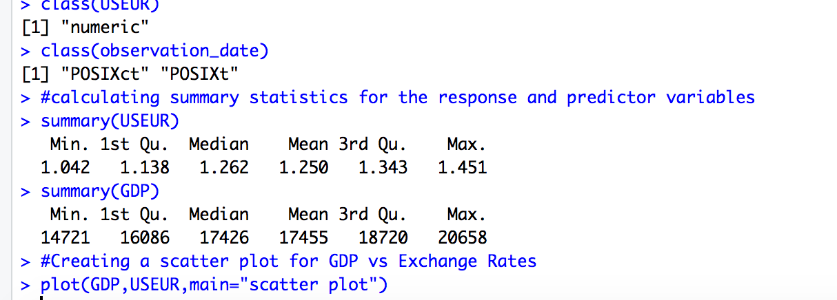

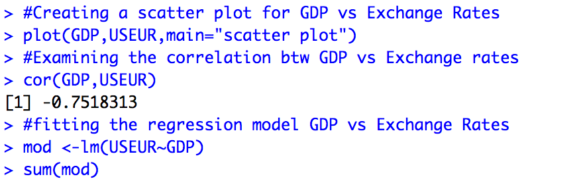



***Code output for the linear regression model of GDP vs Exchange Rates (USEUR)***



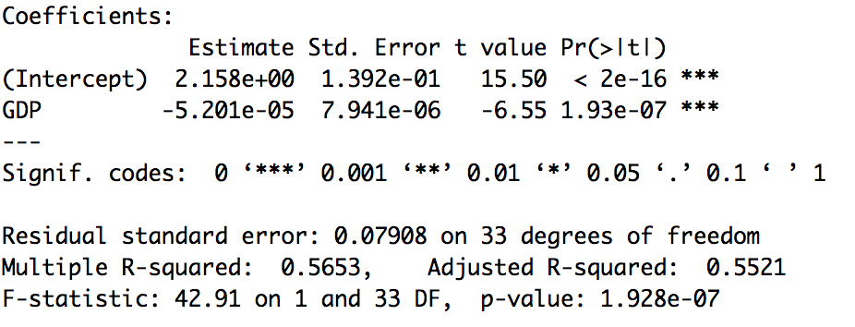

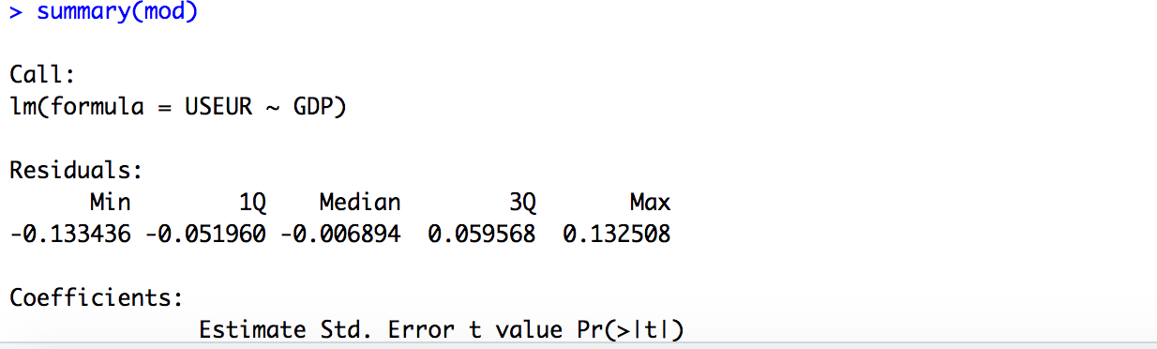

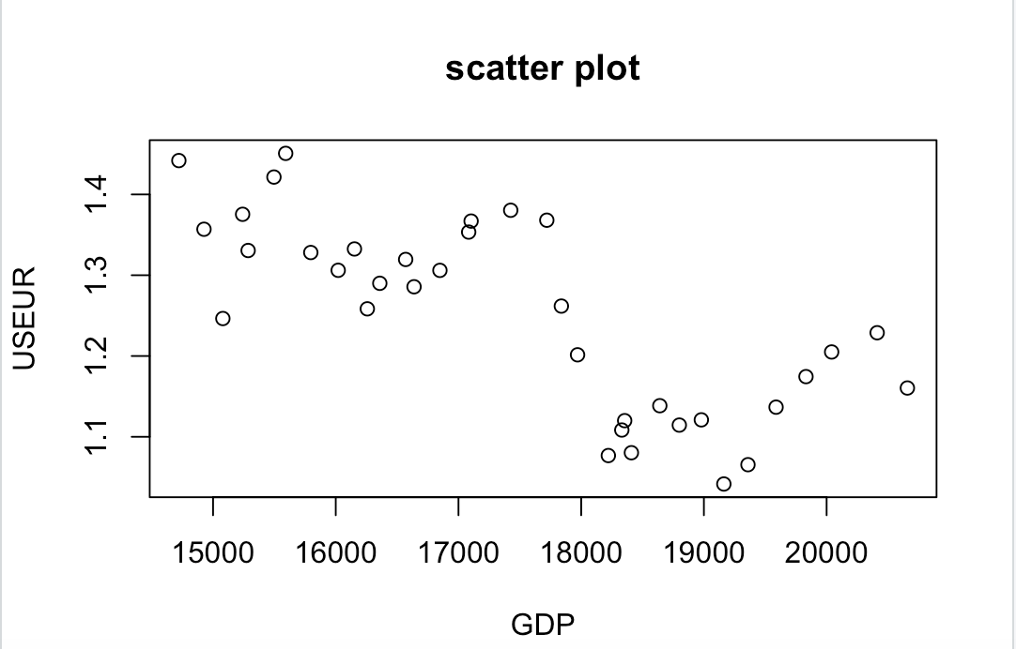

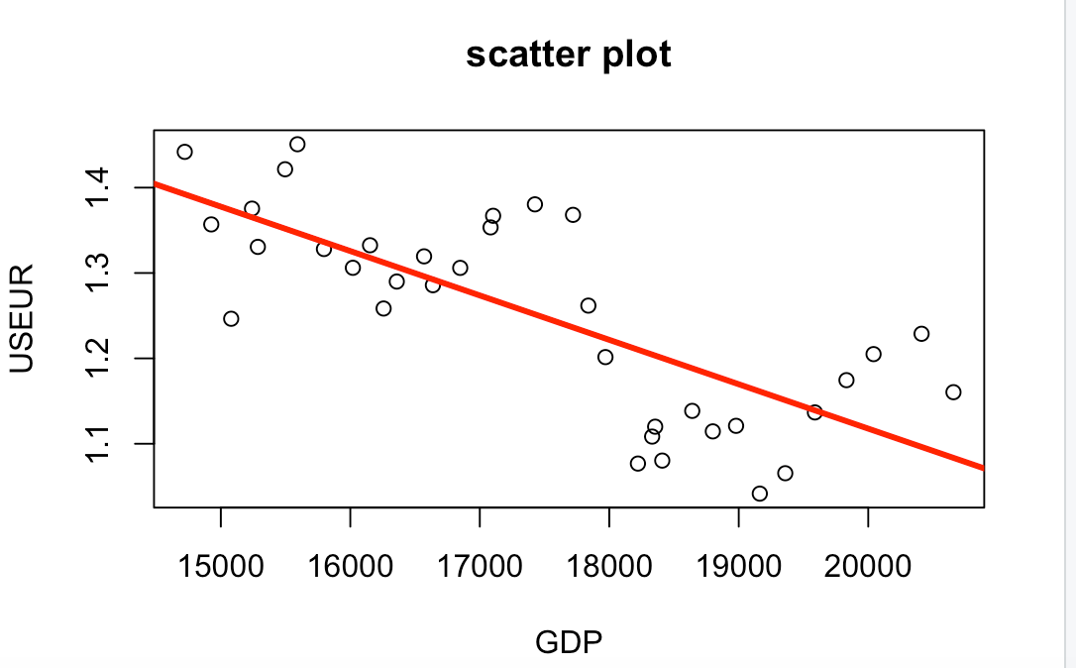

***Interpretation of the results of the linear regression model***

Based on the correlation coefficient of -0.7518313 and the data points on the scatter plot, one can safely infer that there is an inverse linear relationship between GDP and exchange rates. The strength of this relationship though is moderate. In other words, there is a moderate negative relationship between GDP values and exchange rates over time. The regression line (ab line) sloping downward from left to right on the scatter plot also confirms this negative relationship.

This negative correlation between GDP and Exchange rates inferred from this model is contrary to the normal real-world expectation where higher GDP values are associated with higher exchange rates. However though, there are situations where countries with rising GDPs deliberately keep their exchange rates low in order to gain a trading advantage since their exports will be relatively cheaper. Also rising GDP could artificially cause inflation in a country forcing the central bank to act to keep the exchange rate low as a means of curbing inflation and stay competitive.

***R code and output for the hypothesis test of correlation between GDP vs Exchange rate USEUR***

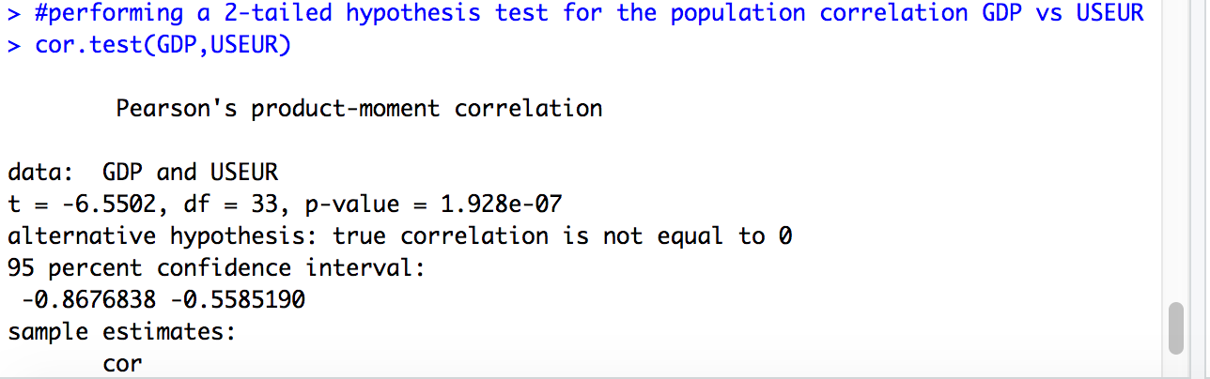

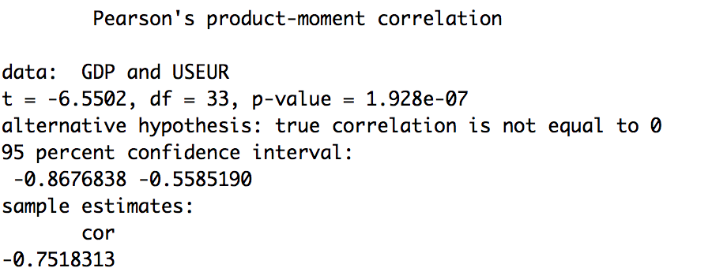

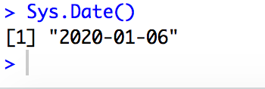

***Interpreting the results of the hypothesis test.***

Given the p-value of 1.928e-07 or 0.0017581 at 95% confidence interval or 0.05 level of significance(alpha), we see that the p-value is slightly less than alpha, therefore we reject the null hypothesis in favor of the alternative hypothesis. In other words, sufficient statistical evidence exists to suggest that there is a relationship between GDP and Exchange rates-USEUR, even though this relationship is negative.

References;

T. Davies (2016). The Book of R-*A First Course in Programming and Statistics*.

Dietrich et al (2015). Data Science and Big Data Analytics. *Discovering, Visualizing and Presenting Data.*

Zybooks(2019). MIS 470-Foundations of Data Science modules 2 & 3.

MIS 470-Foundations of Data Science course website-csuglobal.edu